Security Testing

For any website security, testing is the most important thing. Security testing find out any security issues or bugs. Here we are going to test the following security testing-

• SQL injection testing

• Authentication Testing

|  |  |  |  |  |  |
| --- | --- | --- | --- | --- | --- |
| **No** | **Title** | **Test Steps** | **Expected Result** | **Actual Result** | **Action Taken** |
| 6.1 | Authentication Test | Try to login in as unauthorized or anonymously | Unauthorized user or account cannot access the system | Yes, Login attempt was unsuccessful as unauthorized user. | None |
| 6.2 | SQL injection test | Run SQL injection attack by using havij tools. | The tool cannot get the access of database or table. | SQL injection attack was unsuccessful. | None |

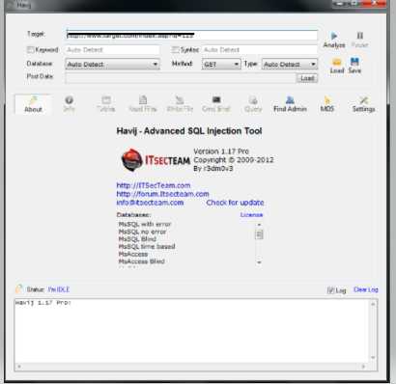

Figure :Squl injection test by havij tool.

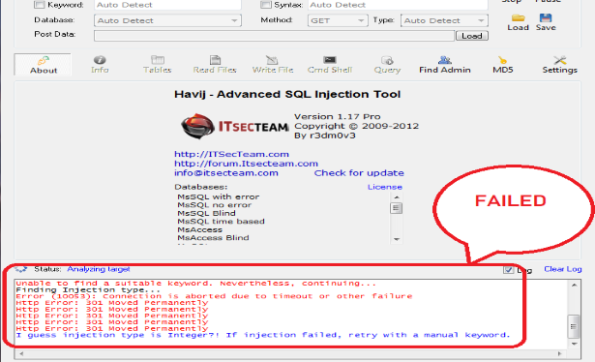



Figure 2: Trying to run the system without login.

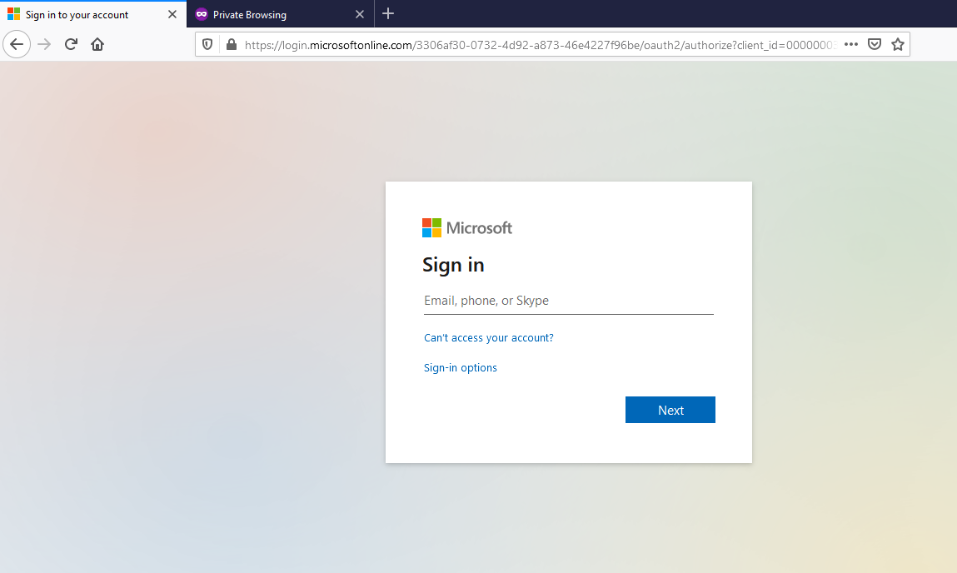

Figure 3: But access denied and redirect to login page



Figure 4: Unauthorized access denied.